**Geometric Designer Abstract Metal Wall Art**

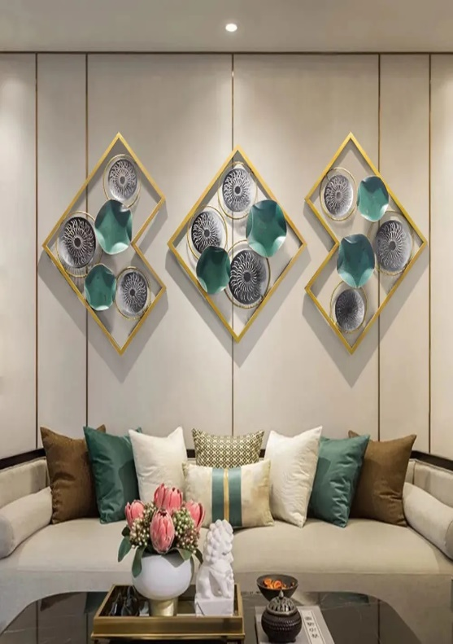Geometric designer abstract metal wall art is a striking fusion of artistry and craftsmanship, designed to elevate contemporary interiors. Featuring bold geometric shapes, intricate cutouts, and layered designs, this metal art creates depth and visual intrigue. Often finished with metallic tones, matte coatings, or textured surfaces, it combines modern aesthetics with timeless appeal. Its durable metal construction ensures longevity, making it suitable for both indoor and outdoor spaces. Ideal for living rooms, offices, or entryways, this art piece adds a dynamic and sophisticated focal point, reflecting a perfect balance of elegance and creativity.